INTERNSHIP REPORT

Understanding Cyber Security Basics & Attack Surface

PRESENTED BY
AISWARYA A M
OBJECTIVE

The primary objective of this internship was to gain a strong foundational understanding of cyber security concepts, threats, and defensive mechanisms in a real-world digital environment.
Specific objectives of this task include
To understand the core principles of cyber security, including confidentiality, integrity, and availability (CIA triad), and their application in real-world systems such as banking and social media platforms.
To identify different types of cyber attackers and understand their motives, techniques, and impact on organizations and individuals.
To explore various attack surfaces such as web applications, mobile applications, APIs, networks, and cloud infrastructure.
To study common web application vulnerabilities by analyzing the OWASP Top 10 and understanding why these vulnerabilities pose serious security risks.
To understand data flow architecture from user to application, server, and database, and identify possible points where cyber attacks can occur.

INTRODUCTION TO CYBERSECURITY

Cyber security refers to the protection of computer systems, networks, and digital data from unauthorized access, cyber attacks, and damage. With the increasing use of the internet for banking, communication, and social networking, cyber security has become essential to protect sensitive information

CIA TRAID
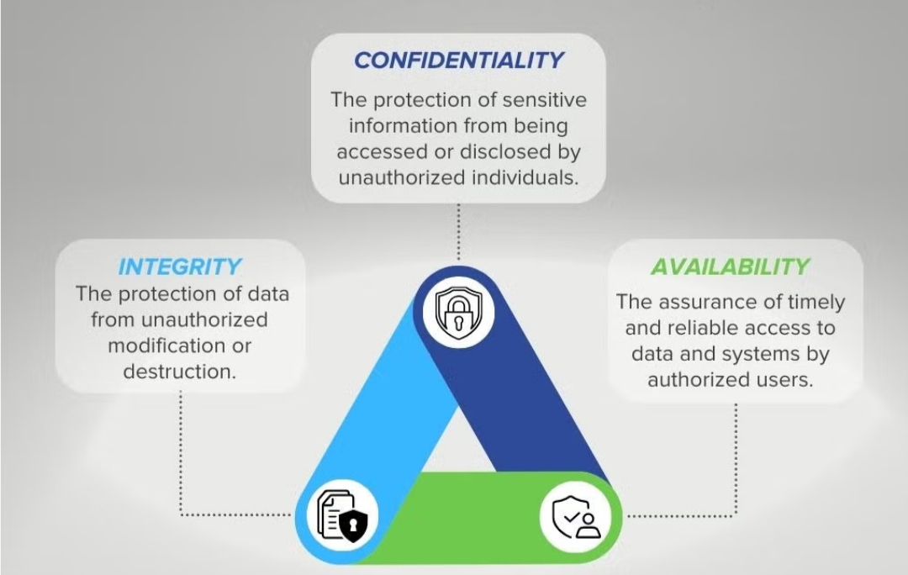
The CIA triad is a fundamental model in information security that consists of three core components: Confidentiality, Integrity, and Availability.
CONFIDENTIALITY
It ensures that only authorized individuals have access to sensitive information. This can include personal data, financial information, or trade secrets. Confidentiality is achieved by implementing security measures such as access controls, encryption, and data masking.
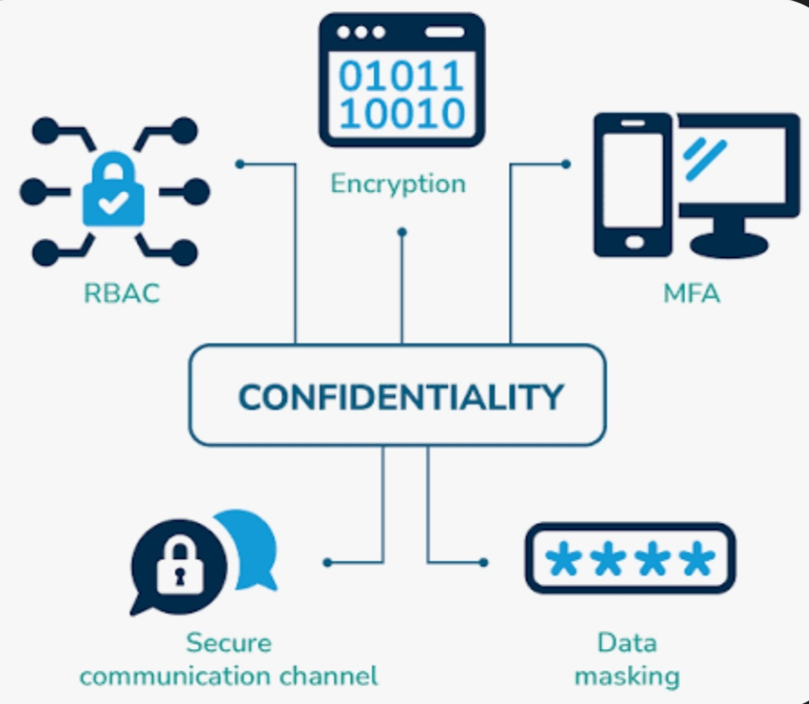
Example
In online banking systems, confidentiality ensures that account details and transaction history are accessible only to the account holder through secure login credentials.

INTEGRITY
It ensures that information remains accurate and trustworthy by preventing any unauthorized changes or tampering.
Example
Integrity ensures that the amount transferred during an online transaction is not altered by attackers.

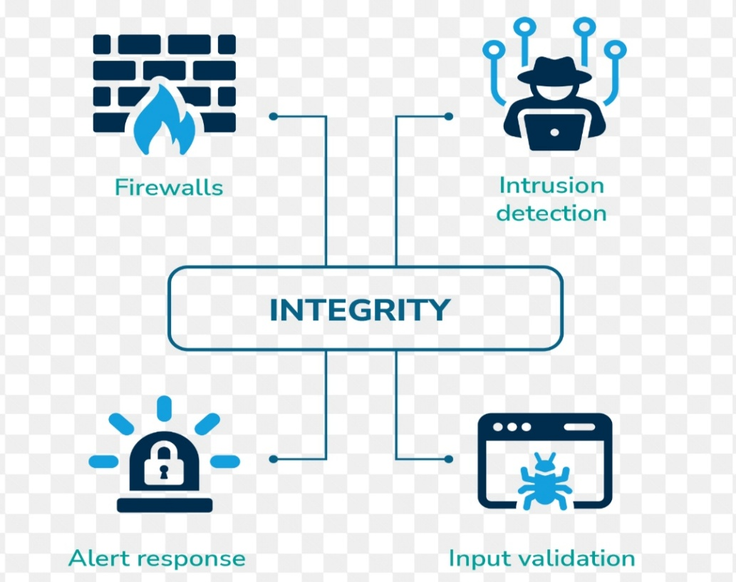

AVAILABILITY
A company may have multiple servers for its website to ensure it stays up and running even if one server fails. They may also have a process in place to regularly back up and test their data in case of a system failure
Example
Banking servers must be available 24/7 to allow customers to access services like fund transfers and balance checks.

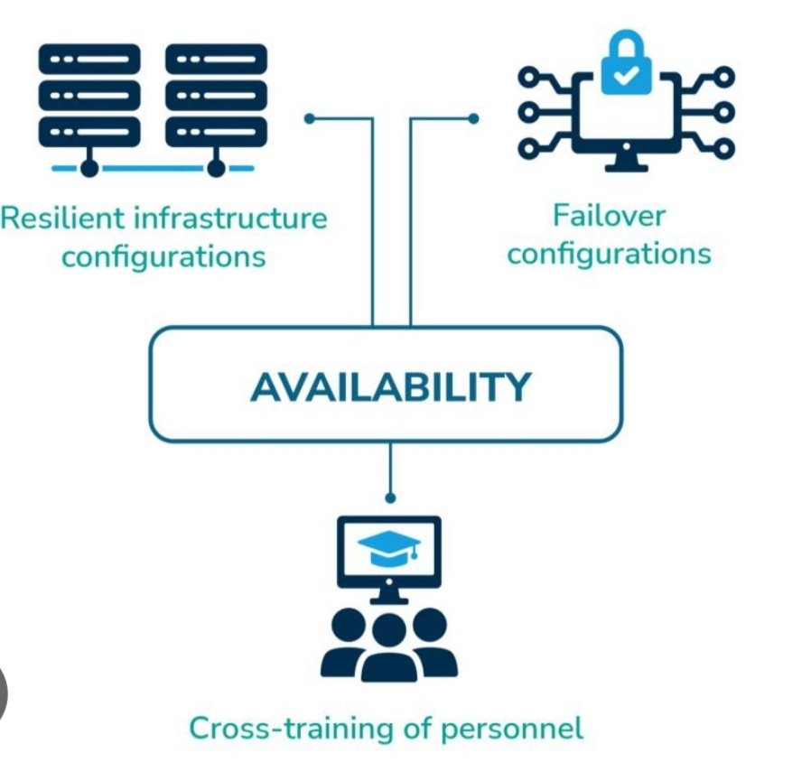

Types of Cyber Attackers

Cyber attackers are individuals or groups who attempt to gain unauthorized access to computer systems, networks, or data. Their motives may include financial gain, revenge, political ideology, or espionage. Understanding the different types of attackers helps in identifying threats and implementing appropriate security controls.

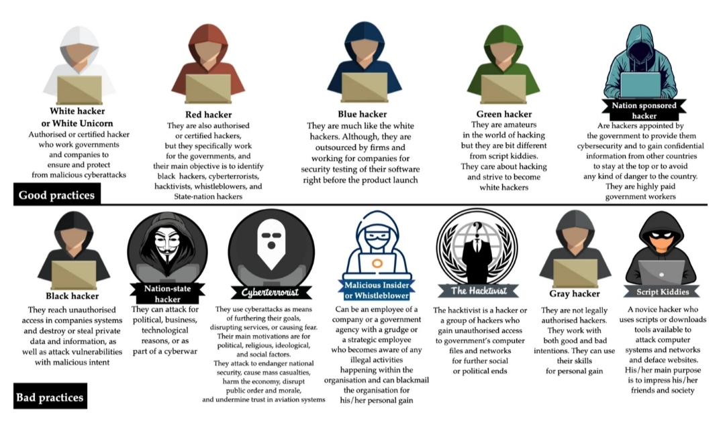

Attackers Type | Description | Skill Level | Motivation | Common Attacks | Example
Script Kiddies | Inexperienced individuals who use ready-made hacking tools and scripts without deep technical knowledge | Low | Fun  Curiosity  Fame | Website defacement, DDoS, basic malware | Using online tools to hack a small website
Insider Threats | Employees or trusted individuals who misuse authorized access | Medium | Revenge, financial gain, negligence | Data theft, data modification, information leakage | Employee stealing customer database
Hacktivists | Attackers motivated by political or social ideology | Medium–High | Political protest, activism | Website defacement, data leaks, DDoS | Attacking government websites
Nation-State Actors | Government-sponsored hackers targeting other nations | Very High | Espionage, national security | APT attacks, infrastructure sabotage | Attacks on power grids or defense systems

Common Attack Surfaces
An attack surface refers to all the possible entry points through which an attacker can attempt to exploit a system. Identifying attack surfaces helps organizations understand where vulnerabilities may exist and apply appropriate security controls.
Web Applications
Web applications are a major attack surface due to direct user interaction through forms and URLs.
Mobile Applications
Mobile apps can be exploited through insecure coding practices or malicious applications.
APIs
APIs are often targeted when authentication and access control are improperly implemented.
Networks
Networks are vulnerable to interception and unauthorized access if not properly secured.
Cloud Infrastructure
Cloud systems are vulnerable mainly due to configuration errors and improper access controls.

Attack Surface | Description | Common Vulnerabilities | Example Attacks | Real-World Example
Web Applications | Websites accessed through browsers | SQL Injection, XSS, broken authentication | Data theft, account takeover | Banking login pages
Mobile Application | Apps running on smartphones | Insecure storage, weak permissions | Data leakage, malware | Payment and social media apps
APIs | Interfaces that allow apps to communicate | Broken authentication, exposed endpoints | Unauthorized data access | Payment gateway APIs
Networks | Communication infrastructure | Open ports, weak passwords | Man-in-the-Middle, sniffing | Public Wi-Fi networks
Cloud Infrastructure | Online servers and storage | Misconfiguration, public access | Data breaches | Cloud-hosted databases

OWASP TOP 10 VULNERABILITY

OWASP (Open Web Application Security Project) Top 10 is a globally recognized list of the most critical web application security risks. Studying these vulnerabilities helps in understanding common weaknesses that attackers exploit and why they are dangerous.
These vulnerabilities are dangerous because they directly affect confidentiality, integrity, and availability of systems. Attackers exploit them to steal data, gain unauthorized access, or disrupt services

OWASP Vulnerability | Description | Why is it Dangerous | Example Impact
Injection (SQL, OS) | Malicious code injected into input fields | Allows attackers to access or manipulate databases | Unauthorized access to user data
Broken Authentication | Weak login and session management | Leads to account takeover | Attacker logs in as a victim
Sensitive Data Exposure | Inadequate protection of sensitive data | Causes data leaks and identity theft | Exposure of passwords or card details
Broken Access Control | Improper restriction of user privileges | Unauthorized actions | Normal user accessing admin data
Security Misconfiguration | Incorrect system or server settings | Opens systems to easy attacks | Default passwords exploited
Cross-Site Scripting (XSS) | Injection of malicious scripts | Session hijacking and defacement | Stealing user cookies
Insecure Deserialization | Unsafe handling of serialized objects | Remote code execution | Server compromise
Using Vulnerable Components | Outdated software libraries | Known exploits can be used | Exploiting old frameworks
Insufficient Logging & Monitoring | Lack of proper tracking | Attacks go undetected | Delayed breach detection
Server-Side Request Forgery (SSRF) | Server makes unauthorized requests | Internal system exposure | Access to internal services

Mapping Daily-Used Applications to Possible Attack Surfaces

Daily-used digital applications such as email, messaging apps, and banking applications are common targets for cyber attacks. Mapping these applications to their possible attack surfaces helps in understanding how attackers exploit user interaction, applications, and networks.

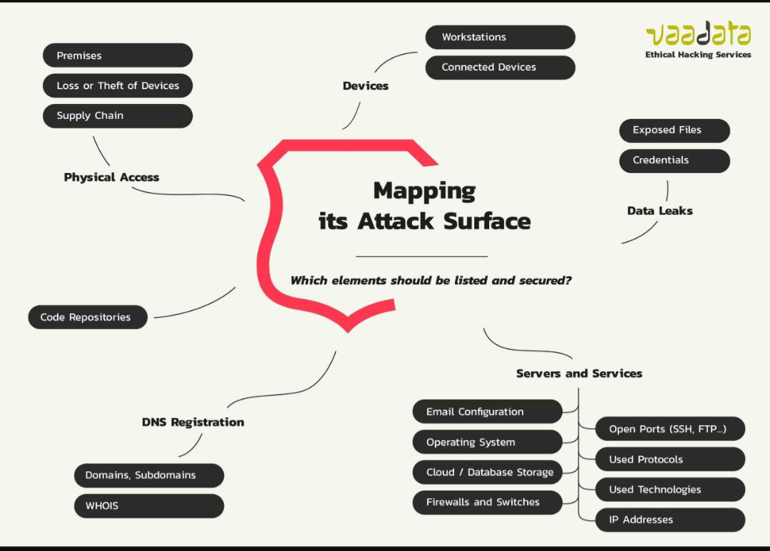

Application | Primary Attack Surface | Possible Threats | Example Attack
Email Services | Web app, attachment , links | Phishing, malware, spoofing | Fake email stealing login credentials
WhatsApp | Mobile app, links, media files | Malicious links, account takeover | Fake OTP request message
Banking Applications | Mobile app, web app, APIs | Credential theft, MITM, fraud | Fake banking website
Social Media Apps | Web app, mobile app | Password reuse, fake profiles | Account hijacking
E-Commerce Apps | Web app, APIs | Payment fraud, data theft | Fake checkout page

DATA FLOW

Data flow describes how information travels through a system from the user to the backend components

Data Flow Diagram
User → Application → Server → Database → Server → Application → User

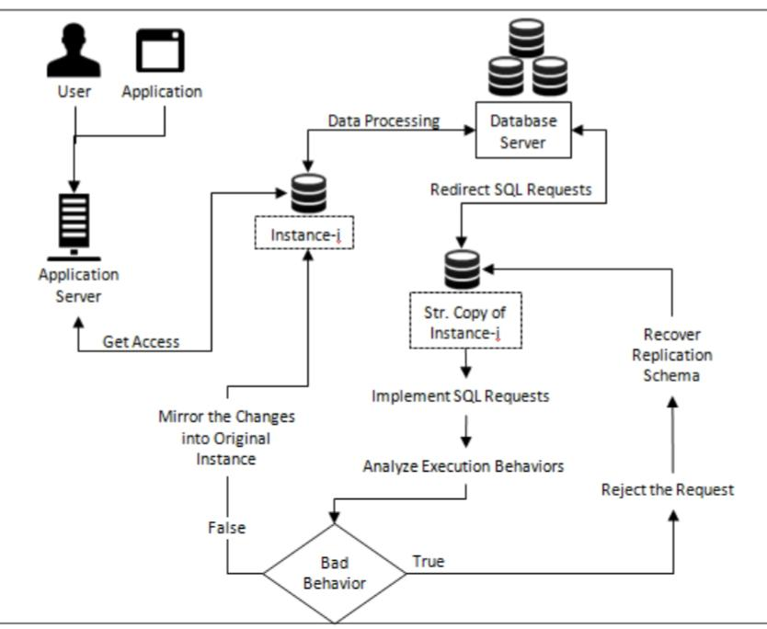

Attack Points in the Data Flow

Cyber attacks can occur at any stage of the data flow. Identifying these points helps in strengthening system security.
Stage | Attack Surface | Possible Attacks | Impact
User | User credentials, device | Phishing, weak passwords | Account compromise
Application | Input fields, UI | XSS, malware | Session hijacking
Network | Data transmission | Man-in-the-Middle | Data interception
Server | Backend logic | SQL injection, RCE | Server takeover
Database | Stored data | Data breach, tampering | Loss of sensitive data

User Level Attacks: Occur through social engineering and credential theft.
Application Level Attacks: Exploit insecure coding practices.
Network Level Attacks: Intercept data in transit.
Server Level Attacks: Target vulnerabilities in backend systems.
Database Level Attacks: Aim to steal or manipulate stored data.

CONCLUSION
Cyber security focuses on protecting systems and data from cyber threats by ensuring confidentiality, integrity, and availability. Different types of attackers such as script kiddies, insiders, hacktivists, and nation-state actors target systems with varied motivations. Common attack surfaces include web applications, mobile apps, APIs, networks, and cloud infrastructure. The OWASP Top 10 highlights critical vulnerabilities that can lead to data breaches and system compromise. Daily-used applications like email, messaging, and banking apps are exposed to multiple attack surfaces. Data flows from the user to the application, server, and database, and attacks can occur at any stage of this flow. Understanding these fundamentals helps in identifying risks and improving cyber security defenses.

